# PUCIT

**Punjab University College of Information Technology**

**MENTOR-HUB**

**Second Deliverable**

**Group Members**

|  |  |
| --- | --- |
| **Name** | **Roll number** |
| Mubashir Ali (Group Leader) | BSEF20A017 |
| Rizwan Abid | BSEF20A006 |
| Ayesha Khan | BSEF20A007 |
| Neha Noveed | BSEF20A026 |
| Aiza Naseer | BSEF20A036 |

**Supervised By:**

**Dr. Madiha Khalid**

**Table of Contents**

|  |  |  |
| --- | --- | --- |
| **No#** | **Topics** | **Page#** |
| 1 | Introduction | **3** |
| 2 | Detailed Use-Case Diagram | **3** |
| 3 | Use-Case Description | **5** |
| 4 | Domain Model | **19** |
| 5 | Sequence Diagram | **20** |
| 6 | Collaboration Diagram | **22** |
| 7 | Operation Contracts | **28** |
| 8 | Design Class Diagram | **33** |
| 9 | Data Model | **34** |

# Introduction

Welcome to the 2nd deliverable, in which we transition from system analysis to extensive use case modeling and Mentor-Hub software design.

This deliverable includes a variety of artifacts to create a comprehensive picture:

* Use Case Explanation
* Use Case Refinement Diagram
* The Domain Model
* Sequence Chart
* Collaboration Graph
* Contracts for Operations
* Create a Class Diagram
* Modelling of Data

We investigate the Mentor-Hub concept's structure, breadth, and features, a platform that connects start-up founders and experienced mentors. This deliverable includes designing a dynamic and collaborative mentorship environment, from complete mentor and user profiles to novel features like City Squads and Machine Learning-driven Matchmaking.

# Detailed Use-Case Diagram

A detailed use case diagram is a vital blueprint for visualizing interactions among system entities.

In the case of Mentor-Hub, a mentorship platform connecting start-up founders with experienced mentors, the detailed use case diagram provides a comprehensive overview of system functionalities and user interactions.

## Primary Actors:

1. Mentor: Experienced professionals willing to provide mentorship.
2. Mentee (User): Individuals or teams seeking guidance for start-up ventures.

## Secondary Actors:

1. Admin: Responsible for system management and issue resolution.
2. Bank: Facilitates payment transactions within the platform.

**Use-Cases names:**

|  |  |  |  |
| --- | --- | --- | --- |
| ID | Name | ID | Name |
| UC-1 | Registration | UC-9 | Engage in Chatbot conversation |
| UC-2 | Login | UC-10 | Resource Exchanges |
| UC-3 | Manage Profile | UC-11 | Notification |
| UC-4 | Manage Mentor-Insights Hub | UC-12 | FAQ |
| UC-5 | View Mentor-Insights Hub | UC-13 | Give/View Rating And Reviews |
| UC-6 | Discover Mentor | UC-14 | Report issue and complaint |
| UC-7 | Mentor Selection | UC-15 | Investigate and Resolved issue |
| UC-8 | Pay though Online Payment Gateway | UC-16 | Logout |

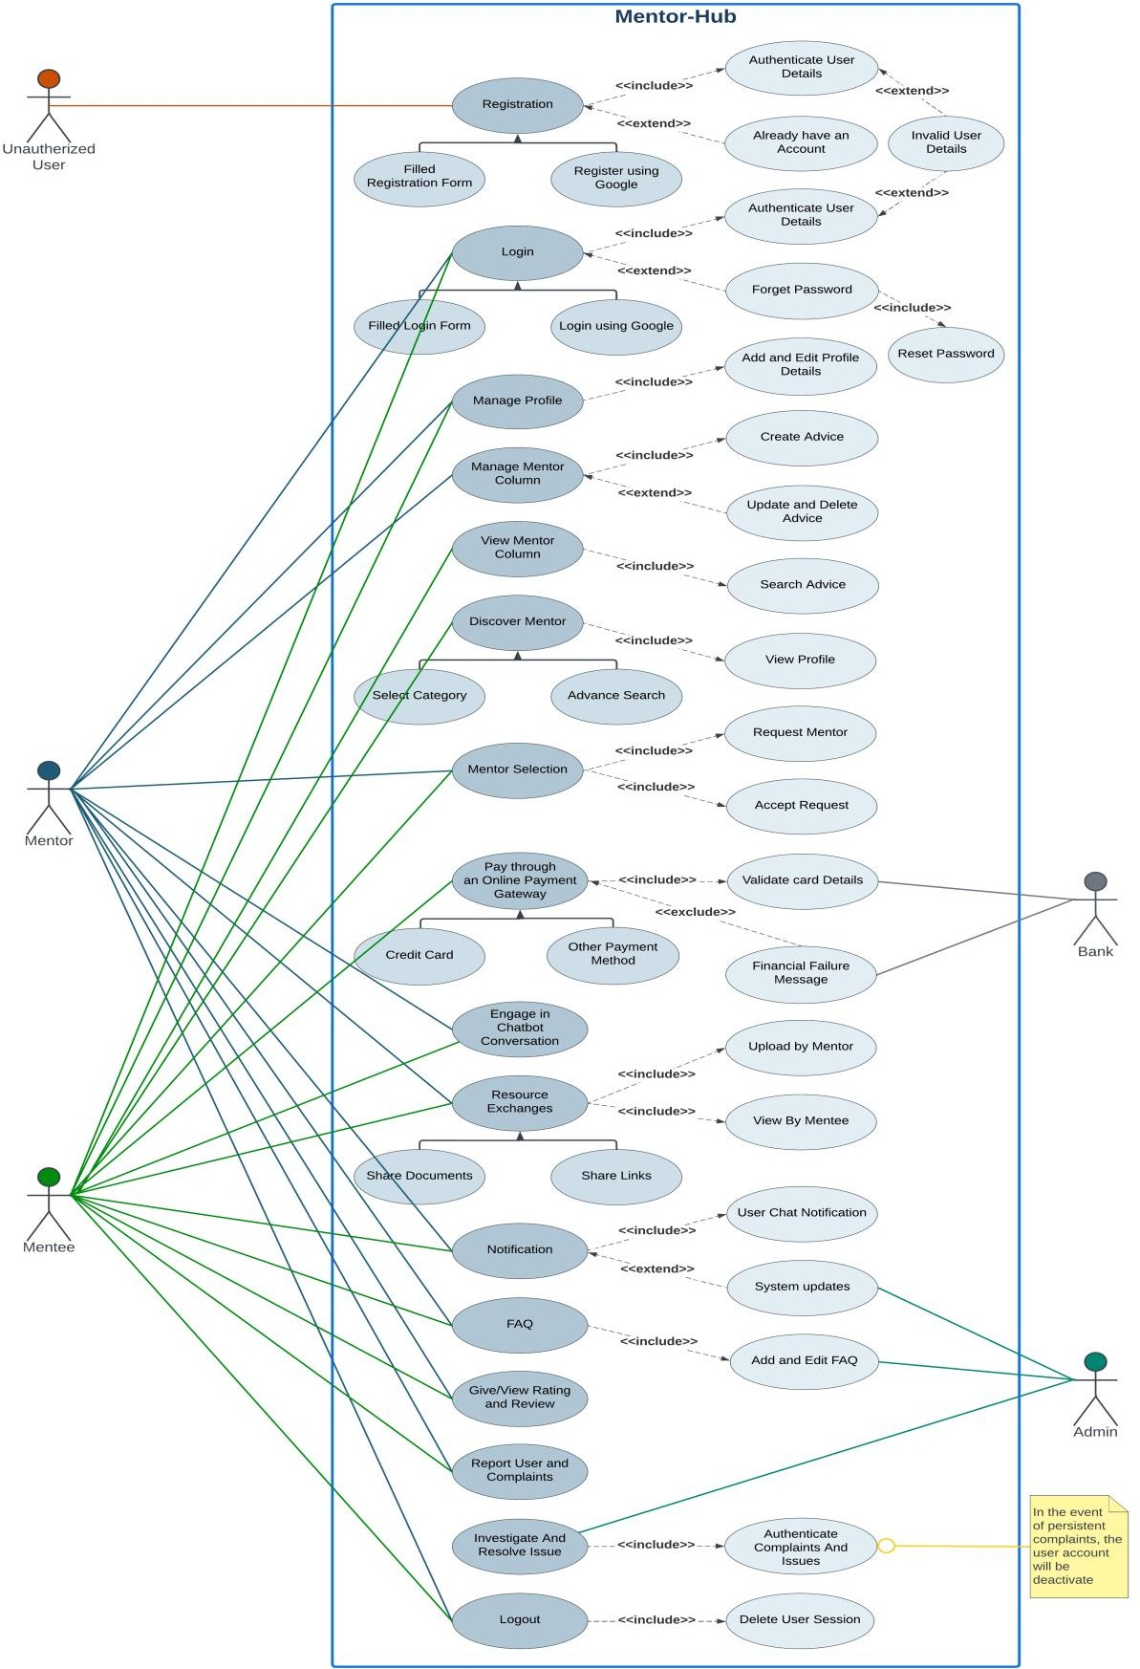

# Use-Case Description

The use-case description is a crucial guide to understand Mentor-Hub's features. It outlines actions for primary and secondary actors, providing a comprehensive view of the system.

|  |  |
| --- | --- |
| **Usecase ID** | **UC-1** |
| Usecase Name | Registration |
| Actor | Mentor, Mentee |
| Type | Primary |
| Usecase Description | The user has to register himself by signing up in the website, if he is visiting for the first time. A user can be a mentor or mentee. In registration form, user will provide username, Email and password. User's details will be verified and after verification, user account will  be created. User can register through Google. |
| Preconditions | Here are the pre-conditions for the "User Registration" use case:   1. User must have a stable internet connection to access the website. 2. User must have a valid and unique email address and username that will be used for account verification. 3. The user should not already have an existing account with the   same credentials. |
| Basic Flow | Here's a basic flow for the user registration process:   1. User will click on the Signup button of the website to register himself. 2. User will register through registration form.    1. User will provide username, email and strong password.    2. The User will agree to the Website's Terms of Service, Privacy Policy and then click on Create Account button. 3. The website validates the provided information and creates   the user account. |
| Alternative Flow | Here's the alternative flow for the user registration process:   1. User can register by using their google accounts. 2. The system will not register the user if the user account already has account. 3. If user enters wrong email or username is not unique, system will display an error message and again registration form will   appear. |
| Post Condition | Here are the post-conditions for the "User Registration" use case:   1. A new user account will be created successfully. 2. The user's login credentials (username, email and password) will securely store in the system database. 3. User will access the dashboard of the website. |

|  |  |
| --- | --- |
| **Use case ID** | **UC-2** |
| Usecase Name | Login |
| Actor | Mentor, Mentee |
| Type | Primary |
| Usecase Description | User will login to the system by adding username and password. The system verifies the user's credentials from the database and allow the  user to use the website. |
| Preconditions | Here are the pre-conditions for the "User Login" use case:  **1.** The user must have a registered account on the website. |
| Basic Flow | Here's a basic flow for the user login process:   1. User will click on the Login button of the website to login to the website. 2. User enters valid login credentials like email and password. 3. System authenticates the entered credentials from website's database. 4. If authentication is successful, the user is logged into the   website and redirected to the home page of the website. |
| Alternative Flow | Here's the alternative flow for the user login process:   1. User can login by using their google accounts. 2. If the user does not already have an account, the system will not login the user and redirect the user to Signup page. 3. If the user enters incorrect login credentials, the system displays an error message and prompts to re-enter the correct credentials. 4. In case of forgot password, the user will click on the link of forgot password.    1. The system will prompt the user to enter his registered email address.    2. The system sends a password reset link to the provided   email address. |
| Post Condition | Here are the post-conditions for the "User Login" use case:   1. The user will successfully logged into the website. 2. User will be redirected to the Home page of the website. |

|  |  |
| --- | --- |
| **Usecase ID** | **UC-3** |
| Usecase Name | Manage Profile |
| Actor | Mentor, Mentee |
| Type | Primary |
| Usecase Description | This use case enables a registered user to manage their profile  information on the website. Users have the ability to create, view, and edit their personal details, contact information, skills, tools and |

|  |  |
| --- | --- |
|  | projects. |
| Preconditions | Here are the pre-conditions for the "User Manage Profile" use case:  **1.** The user must have to login to the website. |
| Basic Flow | Here's a basic flow for the user manage profile process:   1. The user navigates to the profile management section within the website. 2. The system displays the user's current profile information, including personal details, contact information, skills, tools and projects. If the user is a new, the user will create a profile by entering authentic information in these sections of the profile. 3. User can edit required profile information (such as name, contact details, profile picture, skills, projects).    1. The system will display an editable form with the profile information.    2. After editing, user will submit the updated information. 4. The system saves the changes to the user's profile   information. |
| Alternative Flow | Here's the alternative flow for the user manage profile process:  **1.** |
| Post Condition | Here are the post-conditions for the " user manage profile " use case:   1. The user's profile is successfully created. 2. If user edited the profile information, it will be stored in database. |

|  |  |
| --- | --- |
| **Usecase ID** | **UC-4** |
| Usecase Name | Manage Mentor Insights hub |
| Actor | Mentor |
| Type | Primary |
| Usecase Description | This use case allows mentors to manage their contributions to a mentor insights hub section on a website, where they can post business advices. The use case includes the ability to add/post advice and the option to delete advice. |
| Preconditions | 1. The mentor must have to login to the website. 2. Mentor must have created profile. |
| Basic Flow | Here's a basic flow for the manage mentor insights process:   1. The mentor will navigate to the mentor insights section within the website. 2. This system displays business advices and solutions posted by multiple mentors. 3. The mentor selects the option to post new advice. |

|  |  |
| --- | --- |
|  | * 1. The system displays a form for the mentor to input their new advice.   2. The mentor enters the content of the new advice.   3. The mentor submits the form.   **4.** Mentor adds advice and his advice will be publicly visible to everyone. |
| Alternative Flow | Here's the alternative flow for the manage mentor insights process:   1. The mentor decided to delete his previously posted advice.    1. The system displays a list of the mentor's posted advice.    2. The mentor selects a piece of advice for deletion.    3. The website prompts the mentor with a confirmation message, verifying their intention to delete the selected advice.    4. If the mentor confirms, the website deletes the selected advice of mentor. 2. Now, mentors deleted advice will not be visible publicly to   everyone. |
| Post Condition | Here are the post-conditions for the " manage mentor insights hub” use case:   1. The mentor's advice will successfully posted or deleted from the mentor insights section. 2. The system will update the display of the mentor insights to   reflect the changes made by the mentors. |

|  |  |
| --- | --- |
| **Usecase ID** | **UC-5** |
| Usecase Name | View Mentor Insights Hub |
| Actor | Mentee |
| Type | Primary |
| Usecase Description | This use case enables mentees to view posts related to business in the mentor insights section on a website. Mentees can access valuable advice and solutions provided by mentors to gain insights into various business aspects. |
| Preconditions | Here are the pre-conditions for the " view mentor insights " use case:   1. The mentee must be logged in to access and view posts in the mentor insights section. 2. There should be an advice available in on the mentee's   relevant subject matter in mentor insights section. |
| Basic Flow | Here's a basic flow for the user view mentor insights process:  **1.** The mentee navigates to the mentor insights section within the website. |

|  |  |
| --- | --- |
|  | 1. The system displays a list of posts related to the mentee subject of search, provided by mentors in the mentor column. 2. The mentee can click on individual posts to read detailed   advice and solutions provided by mentors. |
| Alternative Flow | Here's the alternative flow for the user view mentor insights process:  **1.** If there are no posts available for the relevant search in the Mentor insights section, the system displays a message indicating that there are currently no mentor's advices available for your relevant search. |
| Post Condition | Here are the post-conditions for the " view mentor insights hub" use case:   1. The mentee successfully views advices related to business in the mentor insights section. 2. The mentee reads advice provided by mentors and can search   for specific mentor advice. |

|  |  |
| --- | --- |
| **Usecase ID** | **UC-6** |
| Usecase Name | Discover Mentor |
| Actor | Mentee |
| Type | Primary |
| Usecase Description | This use case allows mentees to discover mentors on a website by exploring mentors based on their preferences and needs. On the other hand, certain mentors will be suggested to the mentee based on the skills of the mentee's profile. The mentee can review the profile of  the selected mentor. |
| Preconditions | Here are the pre-conditions for the " discover mentor " use case:   1. The mentee must be logged in to access and discover mentors on the website. 2. Mentee must have created profile. |
| Basic Flow | Here's a basic flow for the discover mentor process:   1. The mentee navigates to the "Discover Mentor" section within the website. 2. The mentee chooses to search for mentors by selecting a specific category such as mentor name, subject and skills.    1. The system displays a list of mentors specializing in the chosen category.    2. The mentee can search the mentor profile within the selected category, displaying details such as skills, experience, projects and ratings.    3. The mentee can explore mentor profile within the selected category, displaying details such as expertise,   experience, projects and ratings. |

|  |  |
| --- | --- |
|  | 1. The system displays to the mentee a list of mentors suggested by the ML algorithm.    1. The mentee can explore individual profiles within this   list. |
| Alternative Flow | Here's the alternative flow for discover mentor process:  **1.** If no mentor is available based on the selected category, then the system displays a message indicating that no mentor was  found. |
| Post Condition | Here are the post-conditions for the " discover mentor " use case:   1. The mentee successfully discovers mentors based on selected categories. 2. The mentee previews the detailed profile of a discovered mentor. 3. If the mentee decides to proceed, they may initiate request to   the mentor. |

|  |  |
| --- | --- |
| **Usecase ID** | **UC-7** |
| Usecase Name | Mentor Selection |
| Actor | Mentee, Mentor |
| Type | Primary |
| Usecase Description | This use case represents the process where a mentee selects a mentor, initiates a mentorship request, and the mentor has the option to accept  or reject the request. |
| Preconditions | Here are the post-conditions for the "mentor selection" use case:   1. A mentee must be logged in to access and initiate the mentor selection process. 2. Mentees select a mentor after a search and profile review. |
| Basic Flow | Here's a basic flow for the mentor selection process:   1. The mentee selects the option to send a mentorship request to selected mentor.    1. The system confirms the successful sending of the mentorship request to the selected mentor. 2. The mentor receives a notification of the mentorship request.    1. Mentor review the profile skills and related projects.    2. The mentor decides to either accept or reject the mentorship request.    3. The system updates the status of the mentorship request accordingly. 3. The system notifies the mentee of the mentor's decision   (accepted or rejected). |
| Alternative Flow | Here's the alternative flow for the mentor selection process:  **4.** Mentor rejects the mentorship request, the system notifies the |

|  |  |
| --- | --- |
|  | mentee of the rejection. |
| Post Condition | Here are the post-conditions for the " mentor selection" use case:   1. The mentee is notified of the mentor's decision, either accepting or rejecting his mentorship request. 2. If the mentor accepts the request, then mentee will pay   according to mentor. |

|  |  |
| --- | --- |
| **Usecase ID** | **UC-8** |
| Usecase Name | Make Payment |
| Actor | Mentor, Bank |
| Type | Primary, Secondary |
| Usecase Description | This use case describes the process where a mentee makes a payment for mentorship services. Mentee can pay through a credit card and can pay through payment gateways such as JazzCash, EasyPaisa and  PayPak. |
| Preconditions | Here are the pre-conditions for the "make payment" use case:   1. The mentee must be logged in to access and initiate the payment process. 2. The mentee has selected a mentor related to his need. 3. The mentor has accepted the mentee's request for mentorship. 4. Mentee must have bank account or payment gateways accounts. |
| Basic Flow | Here's a basic flow for the make payment process:   1. The mentee chooses a payment method from the options available: credit card or payment gateways. 2. If the mentee selects credit card payment, the system prompts for credit card details.    1. The mentee enters credit card details such as card number, expiration date, CVV.    2. The mentee confirms the payment, indicating their intent to proceed with the credit card transaction.    3. The system processes the credit card transaction. 3. Upon successful credit card transaction processing, the system displays a confirmation message, confirming the   completion of the payment. |
| Alternative Flow | Here's the alternative flow for the make payment process:   1. Credit card details are not valid, the system notifies the mentee and prompts him to re-enter the information. 2. Financial transactions because the mentee account is empty or does not have the required amount.    1. The system generates a financial failure message   detailing the reason for the transaction failure. |

|  |  |
| --- | --- |
|  | **2.2** The system forwards the financial failure message to  the mentee. |
| Post Condition | Here are the post-conditions for the "make payment " use case:   1. Upon successful payment, the mentee gains access to the agreed-upon mentorship services. 2. Mentee can initiate chatbot conversation with mentor. |

|  |  |
| --- | --- |
| **Usecase ID** | **UC-9** |
| Usecase Name | Engage in chat conversation |
| Actor | Mentor, Mentee |
| Type | Primary |
| Usecase Description | Mentee will request Mentor for chat. Mentor will accept request and  then then can engage in conversation. |
| Preconditions | Prerequisites that must be met before a user can engage in conversation on a website are below:   1. The Mentor and Mentee must be registered users. 2. The Mentee must have to pay for chat conversation. |
| Basic Flow | Here's a basic flow for the user chat conversation process:   1. Mentee will request Mentor for conversation. 2. Mentor will accept Mentee request. 3. They will engage in conversation and share valuable information. |
| Alternative Flow | Here's the alternate flow for the user chat conversation process:  **1.** If the Mentor didn’t accept request Mentee can request another Mentor. |
| Post Condition | Here are the post-conditions for the " Engage in chat conversation " use case:  **1.** The Mentor/Mentee gains valuable information, advice or  resources through the chatbot interaction. |

|  |  |
| --- | --- |
| **Usecase ID** | **UC-10** |
| Usecase Name | Share Resources |
| Actor | Mentor |
| Type | Primary |
| Usecase Description | Mentor and Mentee engaged in chat. They exchanged information  and after successful chat and payment Mentor will share resources like docs and links. |
| Preconditions | Prerequisites of share resources use case are below: |

|  |  |
| --- | --- |
|  | 1. The Mentor is logged into the Mentor-Hub platform. 2. The Mentor has relevant resources to share. 3. The Mentor-Hub platform is accessible and operational. |
| Basic Flow | Here's a basic flow for the share resources process:   1. The Mentor navigates to the "Share Resources" section within the Mentor-Hub platform. 2. The Mentor selects the specific resources (documents, links, advice) they want to share. 3. The Mentor specifies the intended Mentee with whom they want to share the resources. 4. The system presents a confirmation prompt, ensuring the Mentor intends to share the selected resources with the specified Mentee. 5. The Mentor confirms the resource-sharing action. 6. The system facilitates the sharing of selected resources with the specified Mentee. |
| Alternative Flow | Here's the alternate flow for share resources process:  **1.** If the Mentor decides not to share resources after the confirmation prompt, the system remains in the current state. |
| Post Condition | Here are the post-conditions for the " Share Resources " use case:   1. The selected resources are successfully shared with the specified Mentee. 2. Both Mentor and Mentee can access the shared resources   within the Mentor-Hub platform. |

|  |  |
| --- | --- |
| **Usecase ID** | **UC-11** |
| Usecase Name | Notification |
| Actor | Mentor, Mentee, Admin |
| Type | Secondary |
| Usecase Description | Users are logged in their accounts. System has some new updates.  These updates will inform to users through notifications. |
| Preconditions | Prerequisites that must be met before notifications on website are below:   1. The User (Mentee or Mentor) is logged into the Mentor-Hub platform. 2. The System Admin has made updates or announcements   relevant to the users. |
| Basic Flow | Here's a basic flow for the notification process:   1. The User logs into the Mentor-Hub platform. 2. The System recognizes that there are new system notifications or updates. 3. The User navigates to the "Notification Center" within the |

|  |  |
| --- | --- |
|  | Mentor-Hub platform.   1. The User views the system notifications that include updates, announcements or relevant information. 2. The User acknowledges the received notifications. |
| Alternative Flow | Here's the alternate flow for the notification process:  **1.** If there are no new system notifications, the User will not receive any updates in the Notification Center. |
| Post Condition | Here are the post-conditions for the " Notification " use case:   1. The User is informed about recent system updates or announcements. 2. The User can access and review system notifications   within the Notification Center. |

|  |  |
| --- | --- |
| **Usecase ID** | **UC-12** |
| Usecase Name | FAQ |
| Actor | Mentor, Mentee, Admin |
| Type | Primary, Secondary |
| Usecase Description | If user can’t understand something about system. There’ll be FAQ  available. Where all the necessary information for the system will be provided. |
| Preconditions | Prerequisites that must be met before accessing FAQ on website are below:  **1.** The User (Mentee or Mentor) is logged into the Mentor-Hub  platform. |
| Basic Flow | Here's a basic flow for accessing FAQ:   1. The User accesses the Mentor-Hub platform. 2. The User navigates to the "FAQ" section, available in the website’s user dashboard. 3. The User explores different categories or sections within the FAQ to find relevant information. 4. If the User has a specific question, they can use the search functionality to find relevant FAQs. 5. The User clicks on a specific FAQ question to view the   detailed answer or information. |
| Alternative Flow | Here's the alternate flow for accessing FAQ:  **1.** If the User does not find the information needed in the FAQ section, they may choose to contact support or seek  assistance through other platform features. |
| Post Condition | Here are the post-conditions for the " FAQ " use case:   1. The User has access to a comprehensive FAQ section containing answers to common questions. 2. The User can efficiently find information and solutions to   common queries within the Mentor-Hub platform. |

|  |  |
| --- | --- |
| **Usecase ID** | **UC-13** |
| Usecase Name | Give Rating and Review |
| Actor | Mentee |
| Type | Primary |
| Usecase Description | After interacting with Mentor, Mentee can give rating and review to  that specific Mentor about how was there chat and resources. Did they helped him or nor. |
| Preconditions | Prerequisites that must be met before a user can successfully Give Rating and Review on the website are below:   1. The User (Mentee or Mentor) is logged into the Mentor-Hub platform. 2. Mentee has engaged in a mentorship interaction. |
| Basic Flow | Here's a basic flow for the Give Rating and Review process:   1. The User participates in a mentorship session or utilizes resources shared by the Mentor. 2. After the interaction, the User navigates to the "Rating and Review" section within the Mentor-Hub platform. 3. The User selects the completed mentorship interaction for which they want to provide a rating and review. 4. The User assigns a rating to the Mentor or the overall interaction based on their satisfaction. 5. The User has the option to provide a written review, sharing details about their experience, the value gained and any feedback for improvement. 6. The User submits the provided rating and review through the   platform. |
| Alternative Flow | Here's the alternate flow for the Give Rating and Review process:  **1.** If the User chooses not to provide a review immediately  after the interaction, they can revisit the "Rating and Review" section later to submit their feedback. |
| Post Condition | Here are the post-conditions for the " Give Rating and Review " use case:   1. The Mentor receives the User's rating and review for the specific interaction. 2. The User's feedback contributes to the overall reputation and credibility of the Mentor. 3. The Mentor-Hub platform maintains a record of ratings and   reviews for quality assurance and improvement purposes. |

|  |  |
| --- | --- |
| **Usecase ID** | **UC-14** |

|  |  |
| --- | --- |
| Usecase Name | Report users and complaints |
| Actor | Mentee, Mentor |
| Type | Primary |
| Usecase Description | Mentor and Mentee had a chat, they exchanged information. But if  they do any inappropriate thing then they’ll have option to report the user. |
| Preconditions | Prerequisites that must be met before a user can report and complaint on the website are below:  **1.** The User (Mentee or Mentor) is logged into the Mentor-  Hub platform. |
| Basic Flow | Here's a basic flow for the user to report and complain:   1. The User navigates to the "Report" section within the Mentor-Hub platform. 2. The User chooses the specific user (Mentee or Mentor) they want to report. 3. The User provides details about the nature of the complaint or the reason for reporting the selected user. 4. The User submits the report through the platform. |
| Alternative Flow | Here's the alternate flow for the user report and complain process:  **1.** If the User faces difficulties while submitting the report  through the platform, there’ll be an option to contact Mentor-Hub support directly for assistance. |
| Post Condition | Here are the post-conditions for the " Report users and complaints " use case:   1. Admin receives the User's report. 2. The reported user is flagged for review by the admin. 3. Admin assess the report, conduct investigations if   necessary and take appropriate actions, which may include warnings, suspensions or account terminations. |

|  |  |
| --- | --- |
| **Usecase ID** | **UC-15** |
| Usecase Name | Deactivate User Account |
| Actor | Admin |
| Type | Primary |
| Usecase Description | If Users have some dispute and they report other user then Admin will investigate the report and will take charge accordingly where he  can even deactivate user account. |
| Preconditions | Prerequisites that must be met before a Admin can successfully Deactivate User Account from the website are below:  **1.** The Admin have access to website and logged into the  website. |

|  |  |
| --- | --- |
| Basic Flow | 1. The Admin navigates to the user management section of the Mentor-Hub platform. 2. The Admin chooses the user account that needs to be deactivated. 3. The Admin reviews the user account details and any relevant information, such as reported issues or violations of platform policies. 4. If the Admin decides to deactivate the user account, they initiate the deactivation process. 5. The Admin sends a notification to the user, informing them about the deactivation of their account. The notification may include the reason for deactivation and any necessary instructions. 6. The user account is deactivated, restricting the user's   access to the Mentor-Hub platform. |
| Alternative Flow | Here's the alternate flow for Deactivate User Account process:  **1.** If there are legal or compliance issues involved in the deactivation process, the Admin may need to follow specific protocols. |
| Post Condition | Here are the post-conditions for the " Deactivate User Account " use case:   1. The user account is deactivated, and the user can no longer access the Mentor-Hub platform. 2. The Mentor-Hub platform maintains a record of the   deactivated account and the reasons for deactivation. |

|  |  |
| --- | --- |
| **Usecase ID** | **UC-16** |
| Usecase Name | Logout |
| Actor | Mentor, Mentee |
| Type | Primary |
| Usecase Description | This use case describes the process where mentee had already seek  the information needed and Mentor already provided the needed information and now he wants to logout form the website. |
| Preconditions | Prerequisites that must be met before a user can successfully logout from website are below:   1. The User is logged into the website. 2. The website is accessible and operational. |
| Basic Flow | Here's a basic flow for the user logout process:   1. The User navigates to the logout option within the Mentor- Hub platform. 2. The system presents a confirmation prompt to ensure the User   intends to log out. |

|  |  |
| --- | --- |
|  | 1. The User confirms the logout action. 2. The system logs out the User, terminating the current session. 3. The User is redirected to the login page. |
| Alternative Flow | Here's the alternate flow for the user logout process:  **1.** If the User decides not to log out after the confirmation prompt, the system remains in the current state. |
| Post Condition | Here are the post-conditions for the "Logout" use case:   1. The User is successfully logged out of the Mentor-Hub platform. 2. Any active sessions and user-related data are cleared   from the system. |

# Domain Model

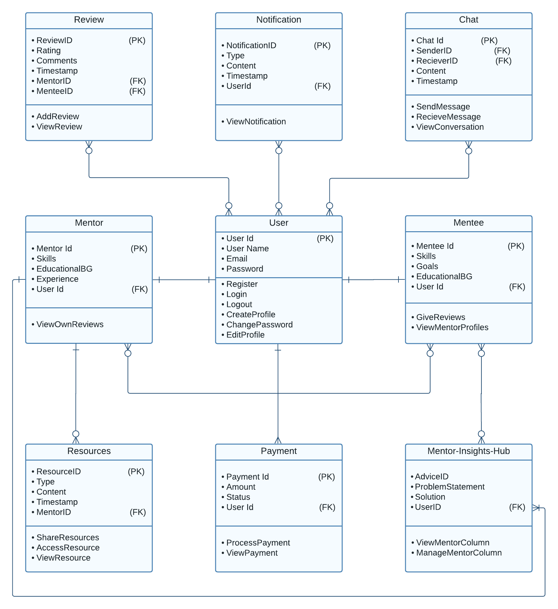

1. **Sequence Diagram**

The sequence diagram is a visual story of how actions unfold in Mentor-Hub. It shows the step-by-step interactions between users and the system

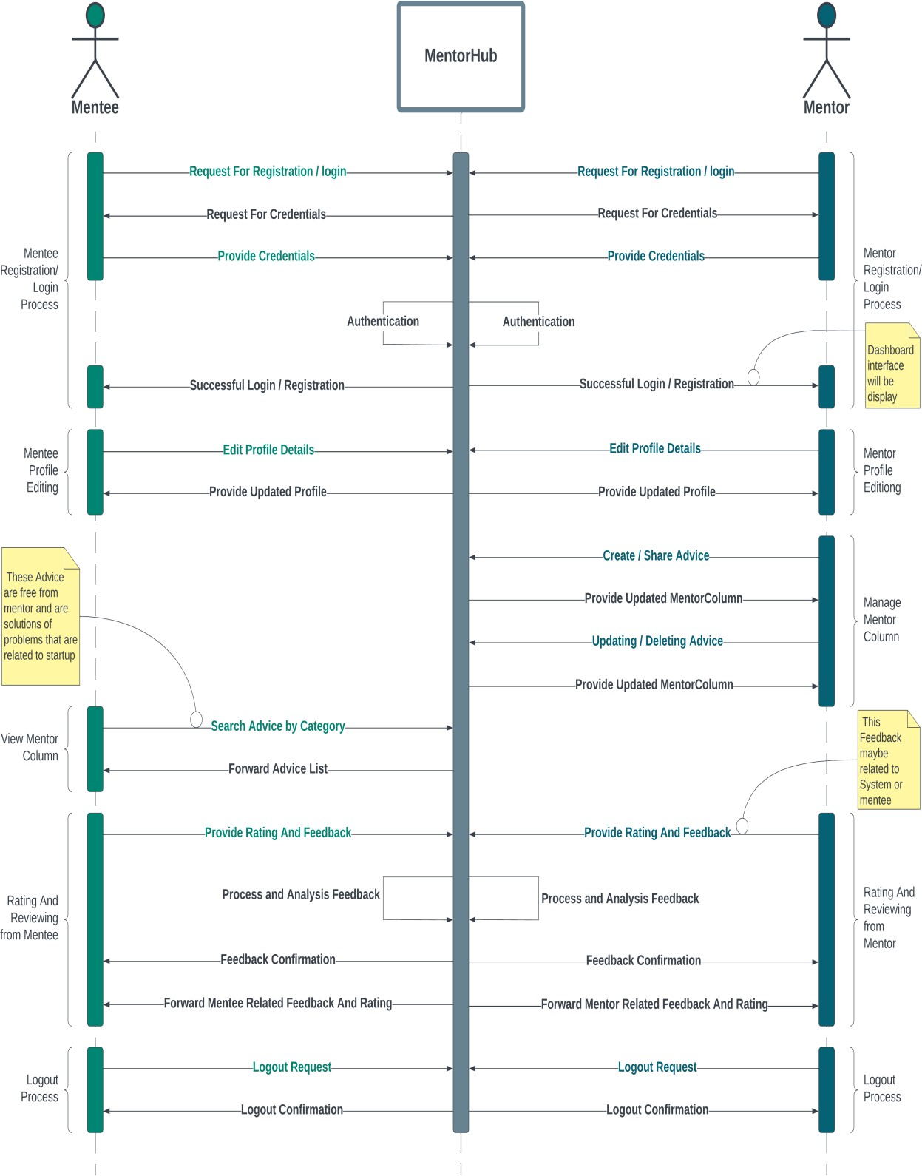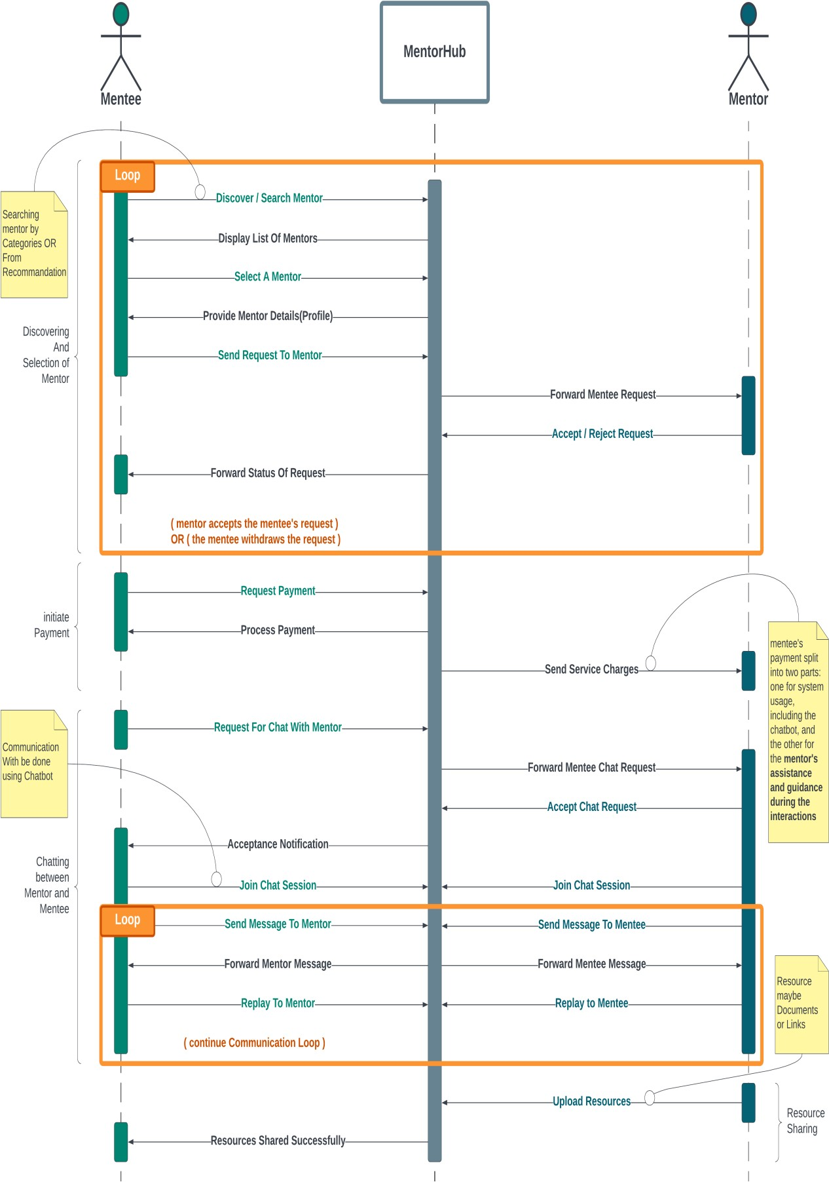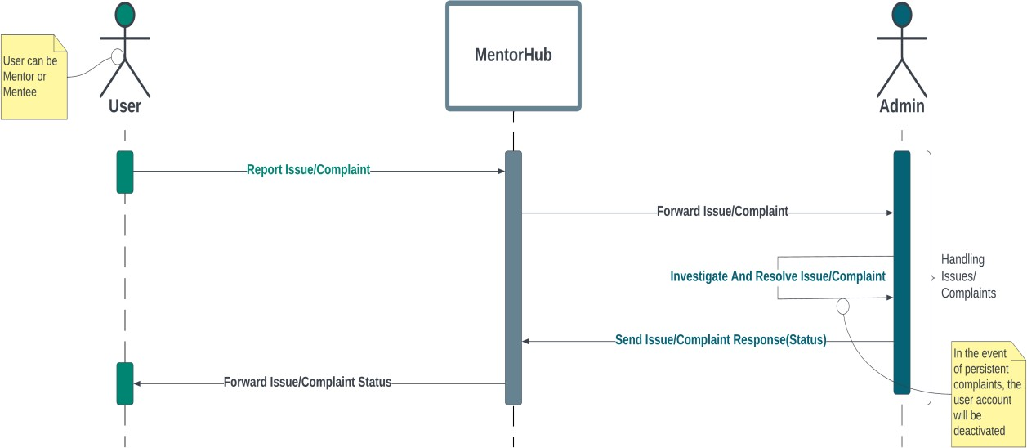

# Collaboration Diagram

The collaboration diagram reveals how different parts of Mentor-Hub work together, illustrating the relationships and interactions among actors and system components

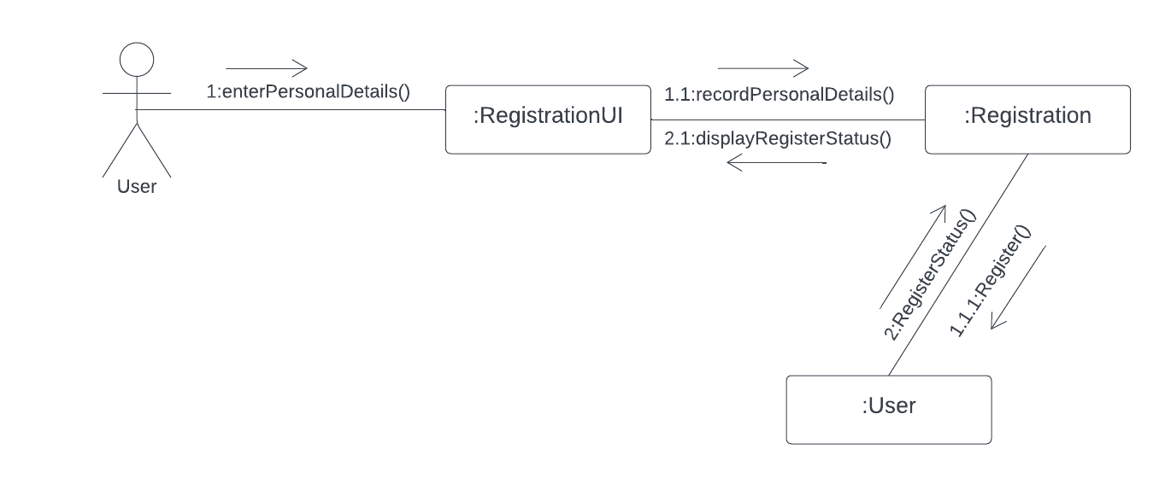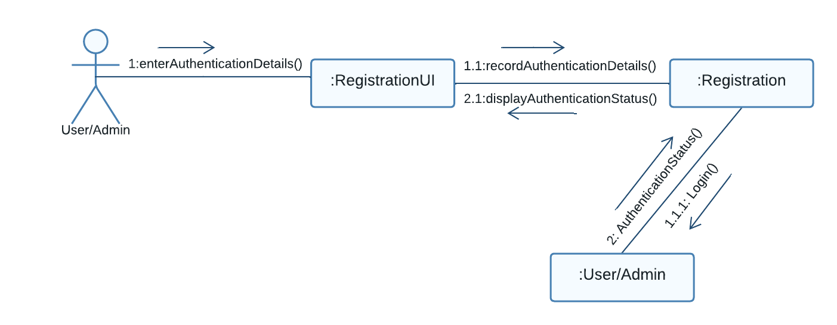

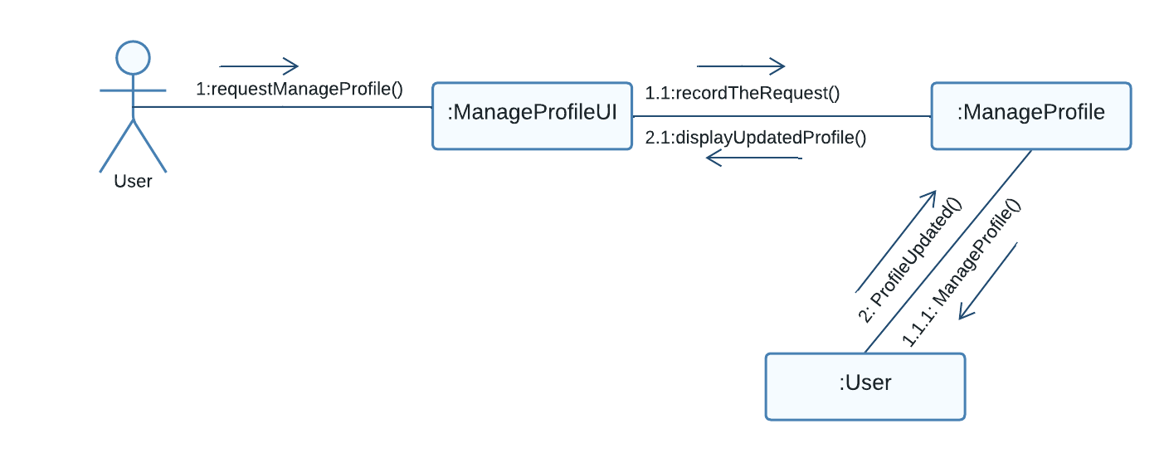

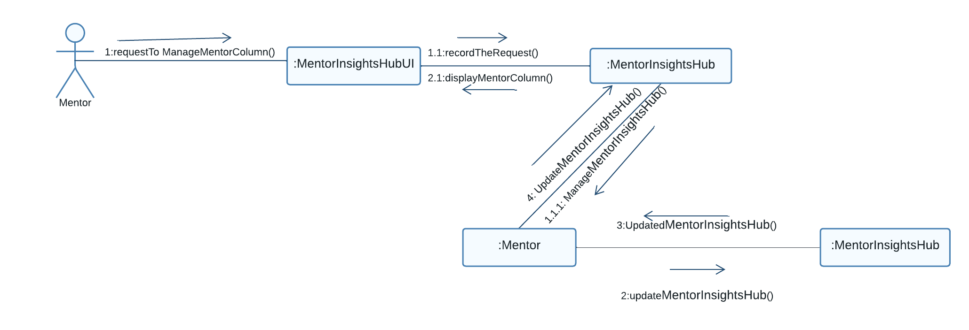

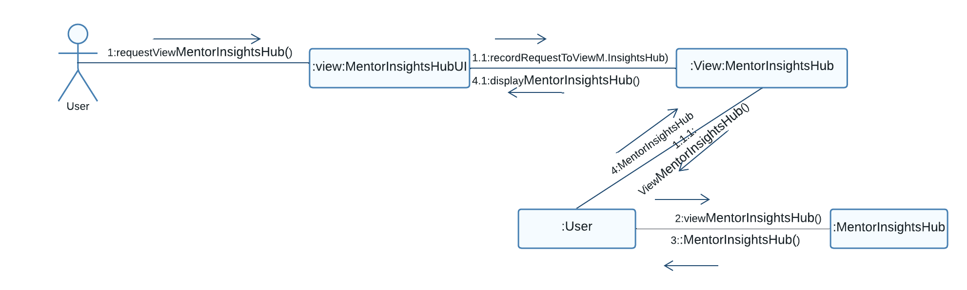

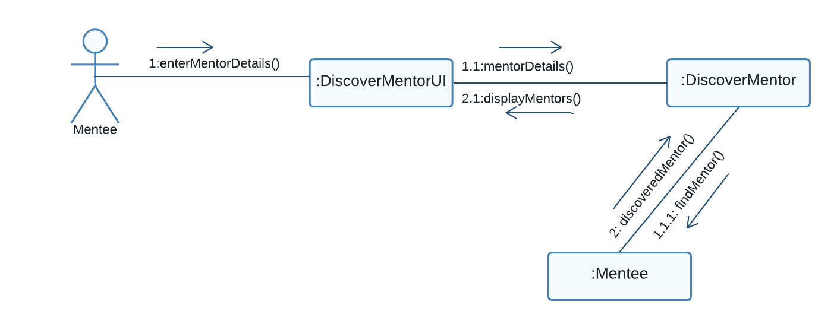

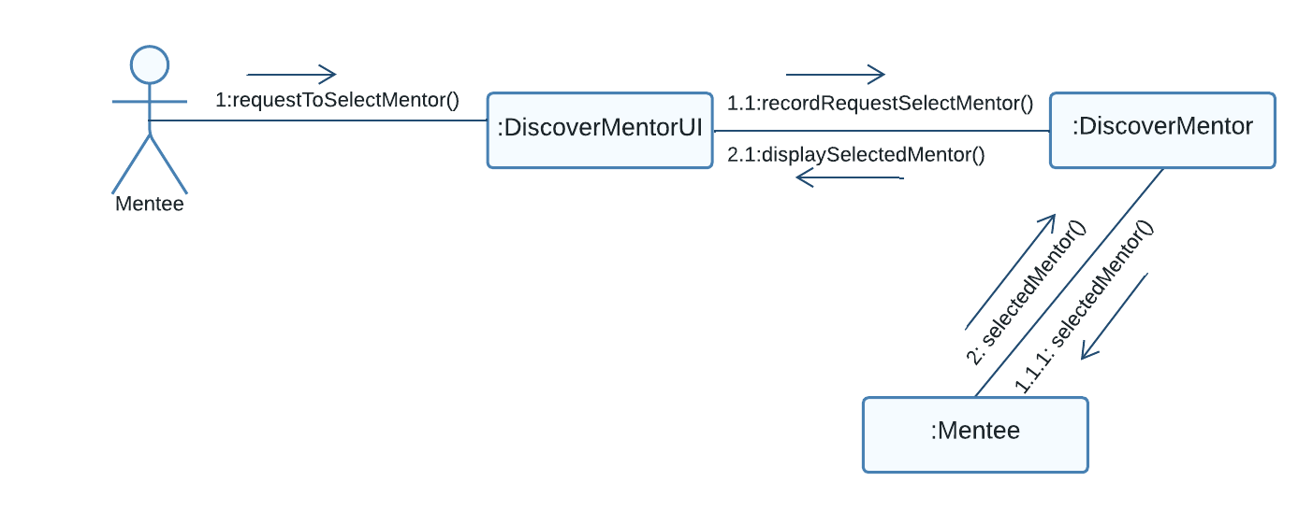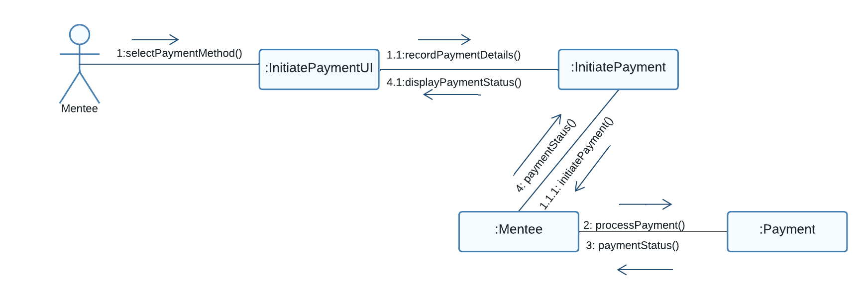

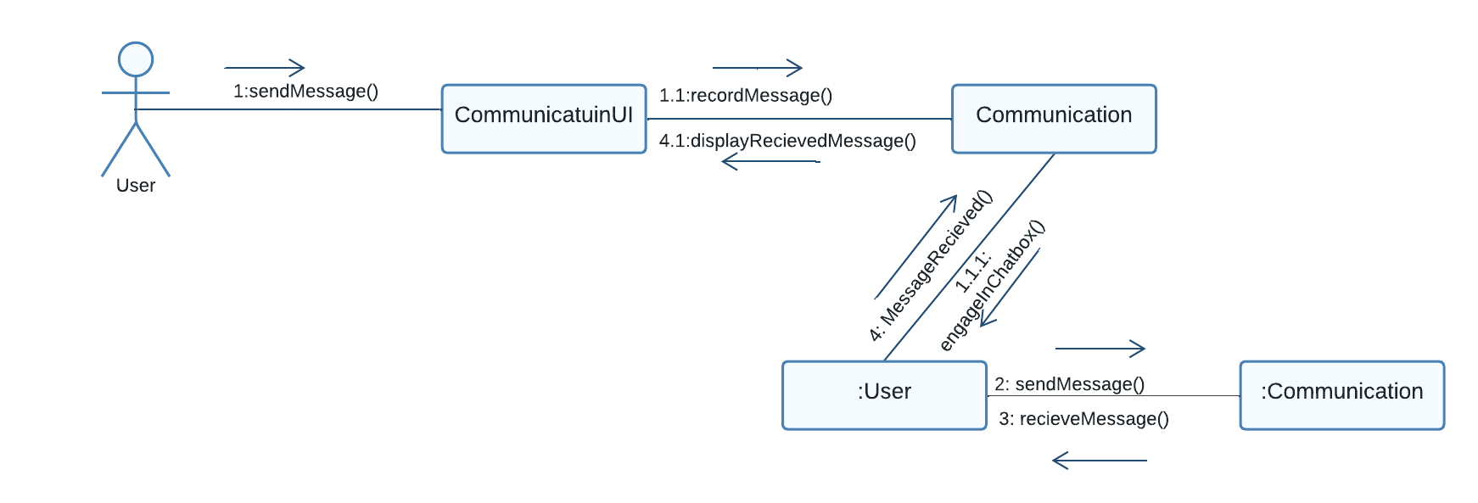

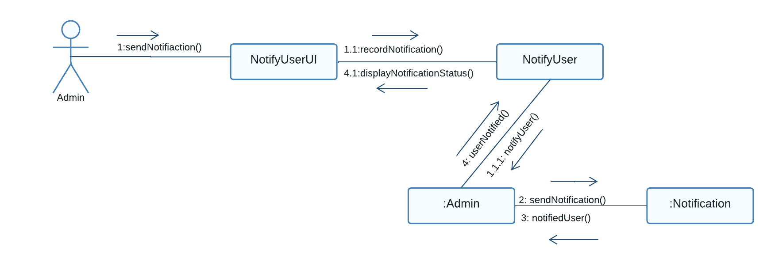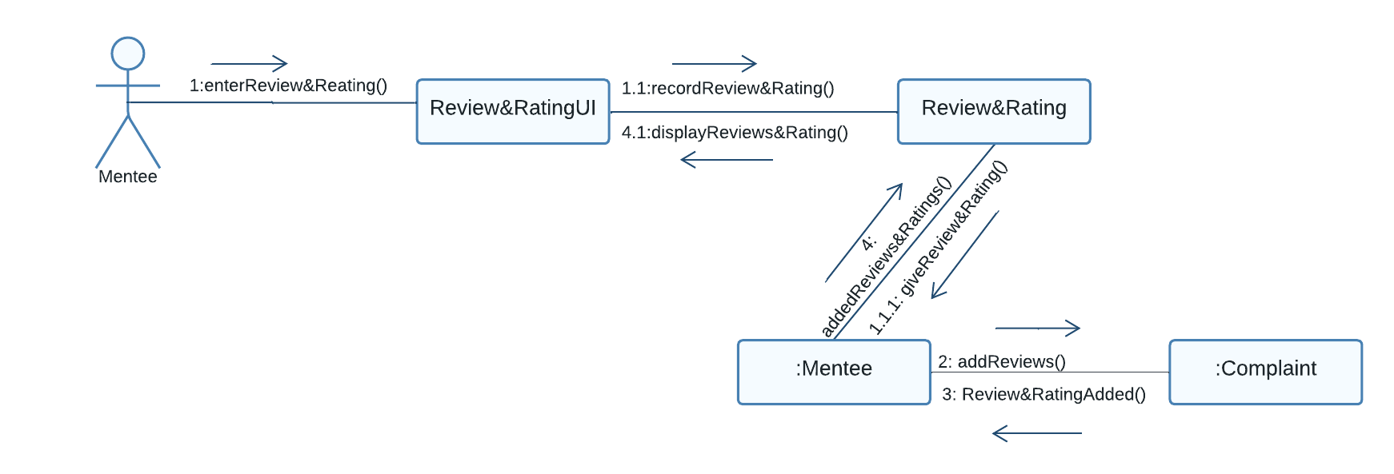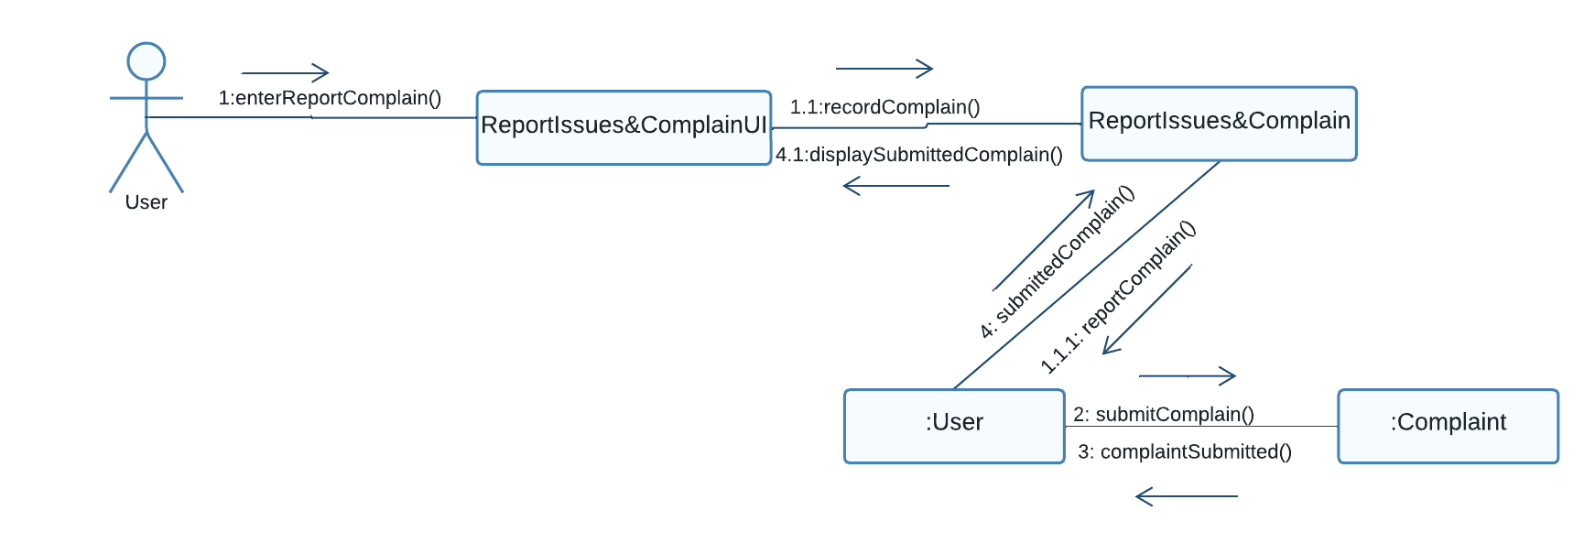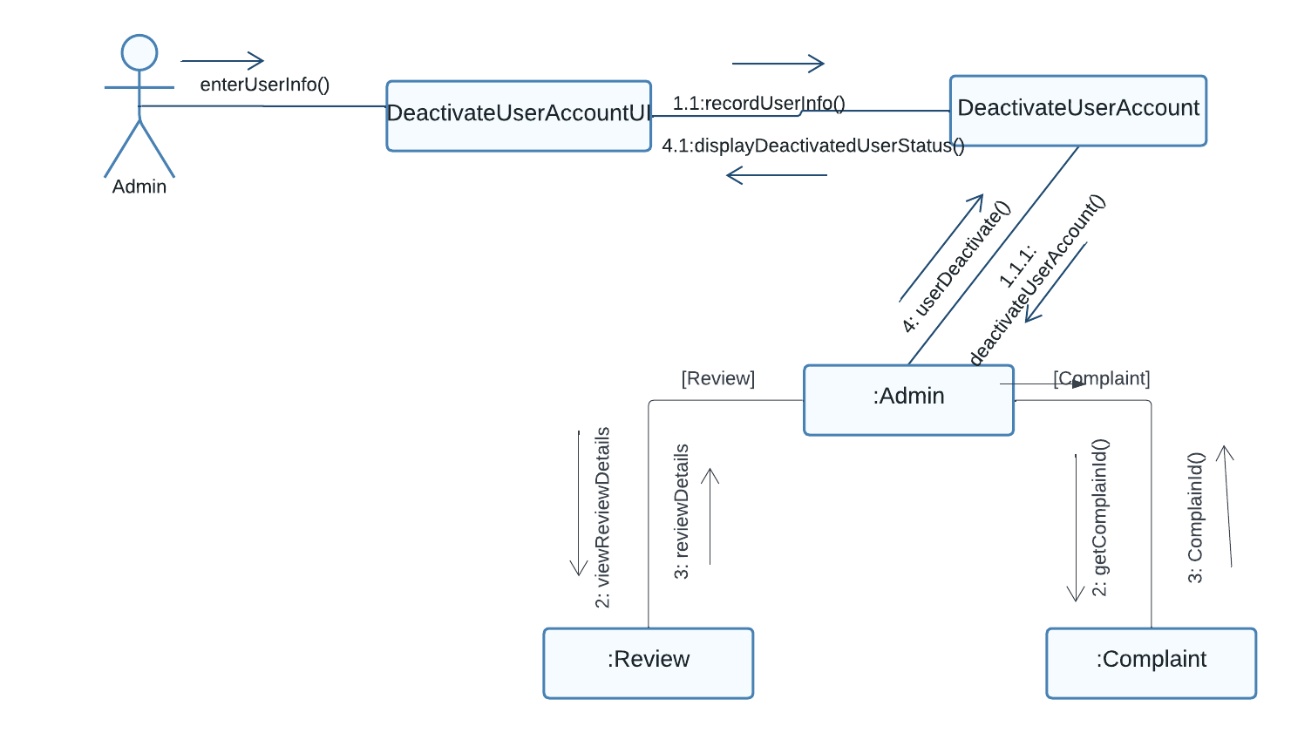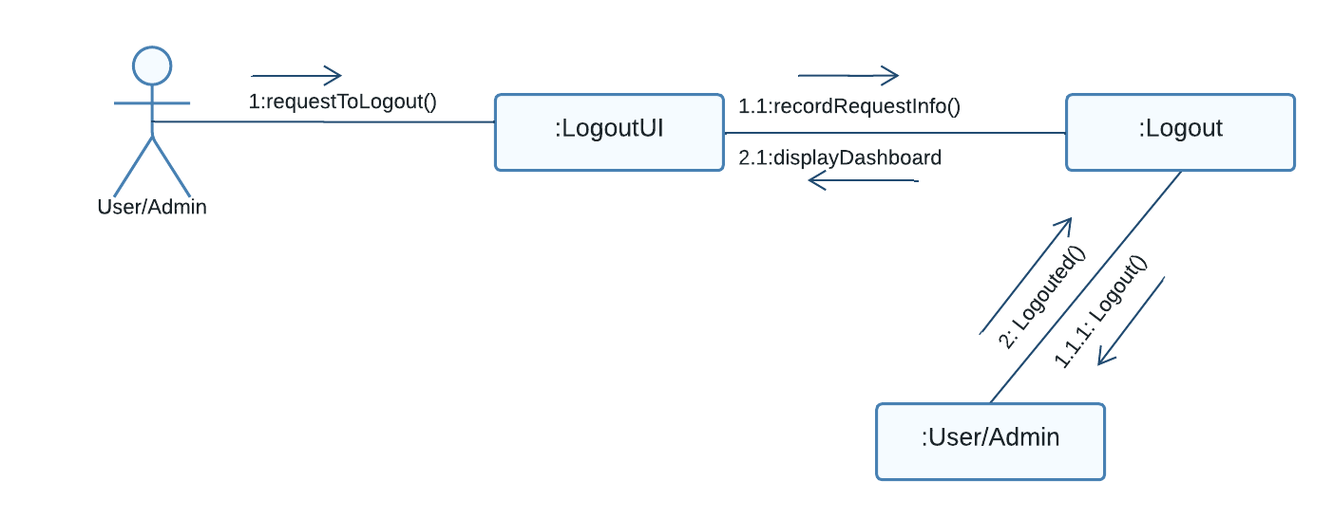

# Operation Contract

The Operation Contract captures the essence of system changes during an operation. It defines the purpose of each operation and helps in detailing what happens when an event occurs.

The contract, derived from a system sequence diagram, focuses on a single event.

|  |  |
| --- | --- |
| **Name** | **Registered User Operation** |
| Responsibilities | Create a new user account, validate details, and grant system access. |
| Cross References | * UC-1 (User Registration) * System functions (User Registration) |
| Exceptions | Invalid email/username prompts, other validations display error  messages. |
| Preconditions | Stable internet, valid email/username, no existing account. |
| Postconditions | Successful account creation, secure storage of login credentials, user  access. |

|  |  |
| --- | --- |
| **Name** | **Validate User Login Credentials Operation** |
| Responsibilities | Verify user credentials, grant access upon successful authentication. |
| Cross References | * Use Case UC-2 (Login) * System functions (User Login) |
| Exceptions | Google account login, redirection to Signup, incorrect credentials,  password reset. |
| Preconditions | Registered account, valid login credentials |
| Postconditions | Successful login, redirection to Home upon authentication. |

|  |  |
| --- | --- |
| **Name** | **Update User Profile Operation** |
| Responsibilities | Update user profile details, including personal information, skills,  and projects. |
| Cross References | * UC-3 (Manage Profile) * System functions (User Profile) |
| Exceptions | Rollback on update error, display error message |
| Preconditions | Logged-in user, navigation to profile management. |
| Postconditions | Successful profile update, saved profile for new entries. |

|  |  |
| --- | --- |
| **Name** | **Manage Mentor Insights Hub Operation** |
| Responsibilities | Enable mentors to add/delete business advice in the mentor Insights. |
| Cross References | * UC-4 (Manage Mentor Insights Hub) * System functions (Mentor Insights Hub) |

|  |  |
| --- | --- |
| Exceptions | **1**-The mentor attempts to delete advice that was not posted by them. **2**-The mentor attempts to copy/paste advice that was not posted by  them. |
| Preconditions | Logged-in mentor, created profile. |
| Postconditions | Successful addition, editing, or deletion of mentor's advice, display  updates. |

|  |  |
| --- | --- |
| **Name** | **View Mentor Insights HUb Operation** |
| Responsibilities | Enable mentees to access and view business advice in the mentor  Insights Hub. |
| Cross References | * Use Case UC-5 (View Mentor Insights Hub) * System functions (Mentor Insights Hub) |
| Exceptions | No relevant advice found. |
| Preconditions | Logged-in mentee, available advice |
| Postconditions | Successful viewing of business advice in the mentor Insights Hub. |

|  |  |
| --- | --- |
| **Name** | **Discover Mentor Operation** |
| Responsibilities | Allow mentees to explore mentors based on preferences. |
| Cross References | * UC-6 (Discover Mentor) * System functions (Discover Mentor) |
| Exceptions | 1. If no mentor is available based on the selected category or Machine Learning suggestions, the system should display a message indicate that no mentor was found. 2. If the mentee does not have a created profile, they cannot utilize the mentor discovery feature such as recommendation based upon mentee skills |
| Preconditions | Logged-in mentee, completed profile. |
| Postconditions | Successful discovery of mentors based on selected categories. |

|  |  |
| --- | --- |
| **Name** | **Mentor Selection Operation** |
| Responsibilities | Initiate mentorship request, notify and handle mentor's response |
| Cross References | * UC-7 (Mentor Selection) * System functions (Mentor Discover/Mentor Selection) |
| Exceptions | Mentor rejects request. |
| Preconditions | 1. The mentee must be logged in to access and initiate the mentor selection process. 2. The mentee has completed the mentor search and profile review process and has selected a mentor for the mentorship request. |
| Postconditions | Notification of mentor's decision, proceed to payment if accepted. |

|  |  |
| --- | --- |
| **Name** | **Make Payment Operation** |

|  |  |
| --- | --- |
| Responsibilities | Initiate and complete payment process for mentorship services. |
| Cross References | * UC-8 (Make Payment) * System functions (Make Payment) |
| Exceptions | Invalid credit card details, insufficient funds. |
| Preconditions | Logged-in mentee, selected and approved mentor, valid payment account. |
| Postconditions | Successful payment, access to mentorship services, and Chatbot  initiation. |

|  |  |
| --- | --- |
| **Name** | **Report Users and Complaint Operation** |
| Responsibilities | Allow Mentees and Mentors to report inappropriate behavior or content of other users. |
| Cross References | * UC-14 (Report Users and Complaint) |
| Exceptions | Report is not submitted by user or facing difficulty in doing that |
| Preconditions | **1**. The User (Mentee or Mentor) is logged into the Mentor-Hub website, select user which he wants to complain, write complain details and submit it. |
| Postconditions | **1**. Admin receives the User's report.  **2**. The reported user is flagged for review by the admin.  **3**. Admin assesses the report, conducts investigations if necessary, and takes appropriate actions, which may include warnings, suspensions, or account terminations. |

|  |  |
| --- | --- |
| **Name** | **Engage In Chat Conversation Operation** |
| Responsibilities | Facilitate Mentee's request for a conversation with a Mentor. |
| Cross References | * UC-9 (EngageInChatConversation) |
| Exceptions | System encounters an error during the initiation of the conversation request |
| Preconditions | 1. User must have a stable internet connection to access the website. 2. The Mentor and Mentee are registered users. 3. Mentor must accept user as his Mentee and Mentee already perform MakePayment operation. |
| Postconditions | The Mentor/Mentee gains valuable information, advice, or resources through the chatbot interaction. |

|  |  |
| --- | --- |
| **Name** | **Mentor Resource Sharing Operation** |
| Responsibilities | Allow a Mentor to share resources (documents, links, advice) with a specific Mentee. |
| Cross References | * UC-10 (Share Resources) |
| Exceptions | Mentee may not access the resources shared by Mentor due to any reason |
| Preconditions | 1. The Mentor is logged into the Mentor-Hub platform. 2. The Mentor has relevant resources to share. 3. The Mentor-Hub platform is accessible and operational.   **3.1** Mentor navigates to the "Share Resources" section.  **3.2** Mentor selects specific resources to share  **3.3** Mentor specifies the intended Mentee.  **3.4** System presents a confirmation prompt.  **3.5** Mentor confirms the resource-sharing action.  **3.6** System facilitates the sharing of selected resource with the specified Mentee. |
| Postconditions | Selected resources are successfully shared with the specified Mentee. |

|  |  |
| --- | --- |
| **Name** | **Notification Operation** |
| Responsibilities | Inform Users (Mentor, Mentee) about new system updates, announcements, or relevant information (New Mentor Resources). |
| Cross References | * UC-11 (Notification) |
| Exceptions | User does not receive notification due to System down |
| Preconditions | 1. User (Mentee or Mentor) is logged into the Mentor-Hub platform. 2. System Admin has made updates or announcements relevant to the users. |
| Postconditions | User is informed about recent system updates or announcements. |

|  |  |
| --- | --- |
| **Name** | **Give Review And Rating To Mentor Operation** |
| Responsibilities | Allow Mentees to give ratings and reviews to Mentors after a mentorship interaction. |
| Cross References | * UC-13 (GiveReviewsAndRating) |
| Exceptions | **Empty Reviews Submission**: Mentee may submit empty reviews or submit such reviews which has no meaning (“Review contains all ......”) |
| Preconditions | 1. User (Mentee) is logged into the Mentor-Hub platform. 2. Mentee has engaged in a mentorship interaction.    1. User participates in a mentorship session or utilizes resources shared by the Mentor.    2. After the interaction, User navigates to the "Rating and Review" section.    3. User selects the completed mentorship interaction for which they want to provide a rating and review.    4. User assigns a rating to the Mentor or the overall interaction based on satisfaction.    5. User has the option to provide a written review.    6. User submits the provided rating and review through the platform. |
| Postconditions | 1. Mentor receives the User's rating and review for the specific interaction. 2. User's feedback contributes to the overall reputation and credibility of the Mentor. 3. Mentor-Hub platform maintains a record of ratings and reviews for quality assurance and improvement purposes. |

|  |  |
| --- | --- |
| **Name** | **Deactivate User Account Operation** |
| Responsibilities | Allow Admin to deactivate a user account based on reported issues or violations of platform policies |
| Cross References | * UC-15 (DeactivateUserAccount) |
| Exceptions | None |
| Preconditions | 1. Admin has access to the website and is logged into the website. 2. Admin navigates to the user management section of the Mentor-Hub platform. 3. Admin chooses the user account that needs to be deactivated. 4. Admin reviews the user account details and any relevant information, such as reported issues or violations of platform policies. 5. If Admin decides to deactivate the user account, they initiate the deactivation process. 6. Admin sends a notification to the user, informing them about the deactivation of their account. The notification may include the reason for deactivation and any necessary instructions. 7. User account is deactivated, restricting the user's access to the Mentor-Hub platform. |
| Postconditions | 1. User account is deactivated, and the user can no longer access the Mentor-Hub platform. 2. Mentor-Hub platform maintains a record of the deactivated account and the reasons for deactivation. |

# 

# Class Diagram

The class diagram illustrates Mentor-Hub's structure, showcasing the relationships and attributes of key components

.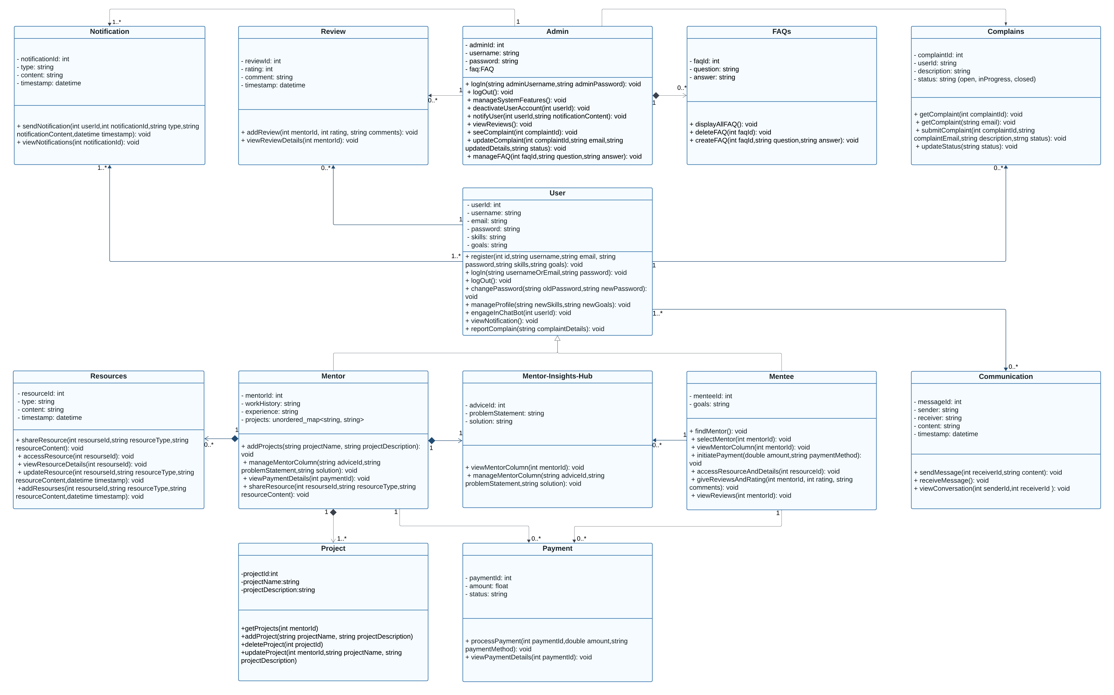

# Data Model

The data model overview is a key reference for understanding how Mentor-Hub stores and manages information. It outlines the structure of data entities, relationships, and attributes.

